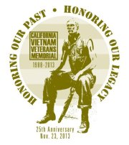
25th ANNIVERSARY OF THE DEDICATION OF THE CALIFORNIA VIETNAM VETERANS MEMORIAL
ALL CALIFORNIA RIDERS
Supporting All Veterans
THUNDER RUN TO THE
CALIFORNIA MEMORIAL

SATURDAY, NOVEMBER 23, 2013
STATE CAPITOL PARK, SACRAMENTO, CALIFORNIA

“Rally, Register and Form up at Raley Field, (West Sacramento)

7:00 am - Pre-registration starts
10:00 am - KSU and Run to the Memorial
1:00 – Ceremony at the CA Vietnam Veterans Memorial
Pre-Registration Fee
$20 for Rider, $10 for Passenger
(Includes Commemorative Pin & Registration for Ride)

For additional Information
Contact:
VVA-500
vietnamveterans@sacvva500.org
or
(916)-481-6020

